rm

rm2

Return Iterator

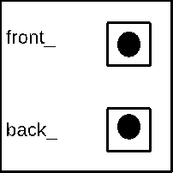



23



15



10



8

